# HTTP and being a webserver

## TCP/IP

We'll talk about TCP and IP, two protocols that are a part of the backbone of the internet.

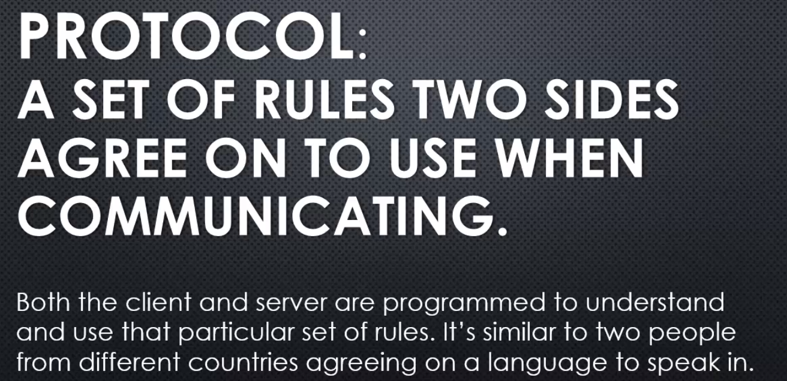

there might be various protocols involved in any particular communication on the internet, but an individual protocol is just that, a set of rules that both sides, client and server, are programmed to understand.

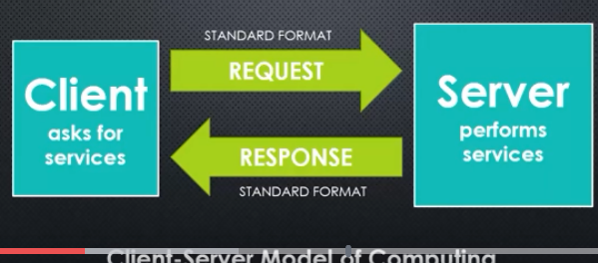

 server performs services, and a client asks for them, probably the browser and web server when it comes to the internet. And there's a request and a response and both the request and the response are in a standard format. That's the client-server model.

**But there's a few questions that have to be answered when we're talking about the client-server model, in particular on the internet.**

How do the client and server identify each other?

And we know there is a standard format for the information being sent, but how is the information actually transferred?

That's where TCP and IP come in.

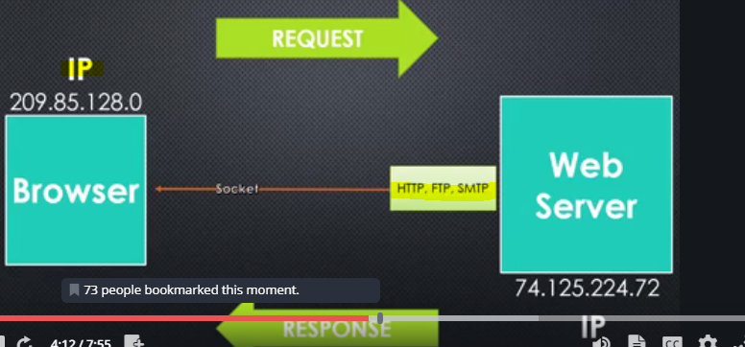

So when the client and the server, usually the browser and the web server, connect, you're probably already familiar with the idea that each computer is assigned an IP address, a sequence of numbers that uniquely identifies that computer.

**IP stands for internet protocol. And at its most basic, since a protocol is a set of rules, IP means we've agreed that this sequence of numbers will be the identifier for how we connect two computer systems together, how we identify which is which that we wish to communicate with. So that at its most simplest is IP.**

When we make that connexion, your operating system's networking ability can open a socket and connect to the other computer. A **socket** is the line across which information flows, if you want to think of it that way. It's where the information actually flows as it's moving from one computer to another. It's the idea of a socket.

**Now that information normally is structured within its own type of protocol, whether it's HTTP, FTP, SMTP, the Ps in all of those stand for protocol, a particular set of rules for how the information is structure, HTTP for web, FTP for files, SMTP for email, and there are others.**

But they're all travelling from computer to computer using internet protocol to identify.

**And then how do we send that information?**

**Because while HTTP and others are protocols themselves, we need a protocol to define how we actually send that information, not just how the information is structured.**

**so the way that information is sent is called TCP or transmission control protocol. And what that means is the information that we're sending, whatever format it's in, whatever protocol is used to structure itself, TCP is the protocol that says we'll take that information and split it into pieces and send those pieces one at a time through the socket from computer to computer, and that individual piece is called a packet.**

**So again, the information itself may be defined by a protocol, what is in this package. But the act of separating it into packets, into small pieces, and sending it along the wire is TCP. And because we need IP to know where to send them, we typically refer to both of these protocols together, TCP/IP.**

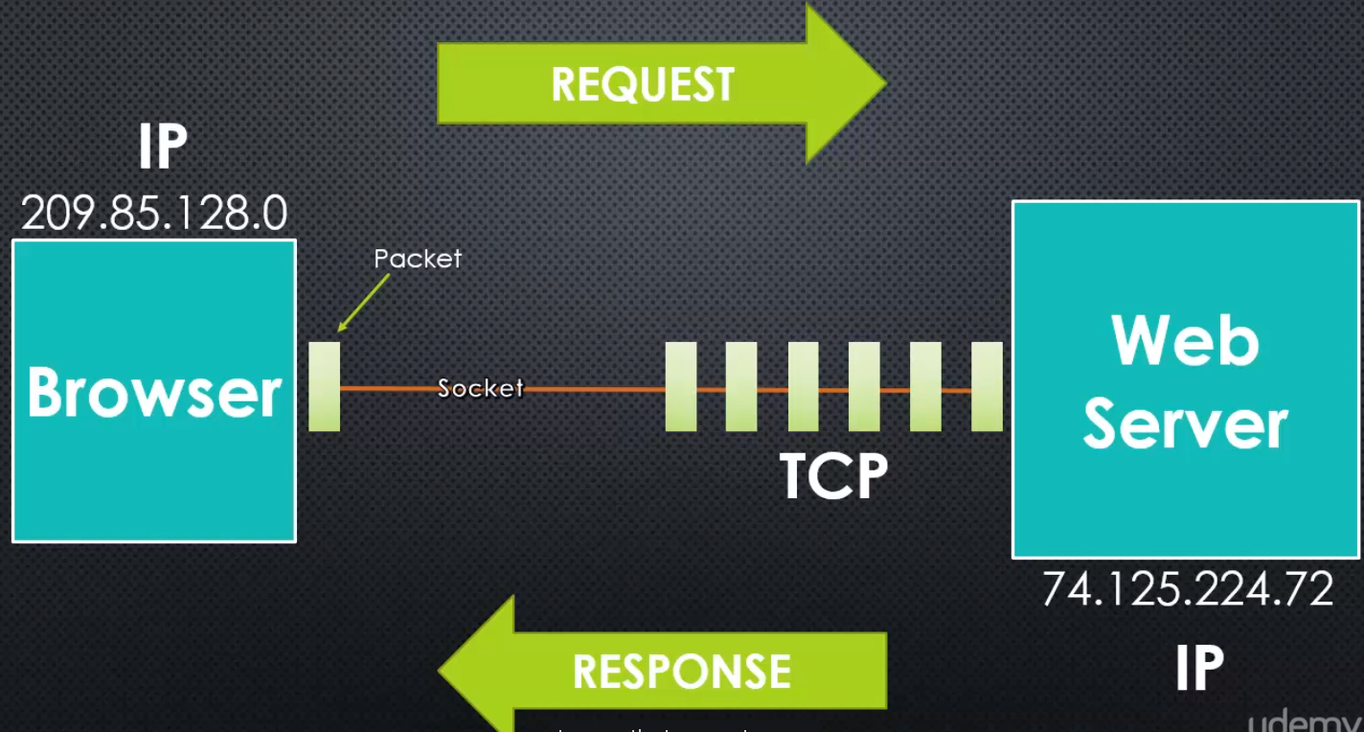

**Your operating system has this capability. And Node then provides the ability to access those features of your operating system, the ability to create a socket and make that network connexion to send information over TCP/IP.**

And so within Node, we can then define the information that we're trying to send.

**We typically think of Node as a web server, but technically you could use Node to build an email server, a file server for sending and retrieving files, and more. But at its heart of any of these kinds of internet communications is this idea of TCP/IP.**

Now **you might be thinking two things. One, TCP looks an awful lot like a stream, a chunk or a segment or a packet as it's called of data being sent at a time.**

And you're right.

**In the end, it's the same concept. It's the idea of a stream.** so because of that, Node treats these packets coming along down the pipeline as a stream,and we'll see that later.

The other thing you may be thinking is, hey, I've heard the term socket, I know about web sockets, or the idea of real time communication on the internet.

Well, sockets, the general idea, have been around for a very long time. We use them all the time, the connexion between two computers for communication.

**However, with the internet, we open and close sockets constantly. We ask for information, receive it, and that socket is closed. And then when we make another request, we click a link, we ask to download an image, then new sockets are opened.**

But the idea of web sockets, which is a newer idea, is to keep the socket open constantly so that both the client and the server can send information to each other whenever they want.

But that's a different subject actually, but it's still underneath the same technology, just meaning when we talk about web sockets, we're talking about keeping the socket open.

But for the purposes of understanding what we're about to do in building a web server, we're talking about simple and standard TCP/IP connexions with sockets that open and close, sending information across them.

**So the idea is that,the web server then perhaps will receive information or the browser will receive information split up as packets and Node chooses to see that as a stream.**

## Address and ports

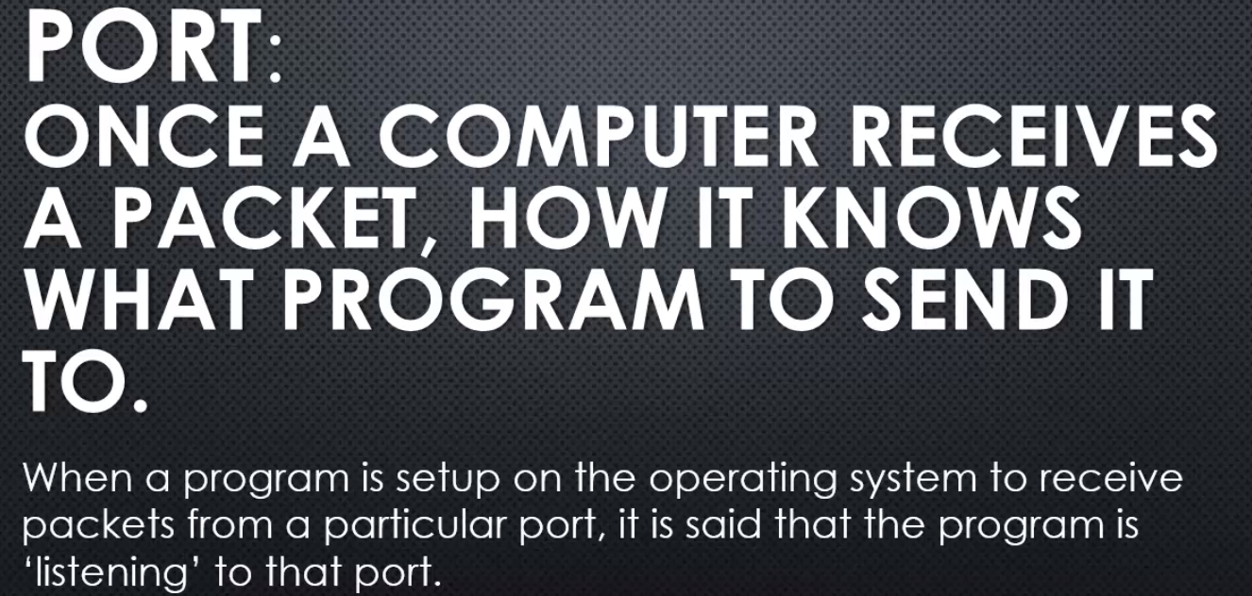

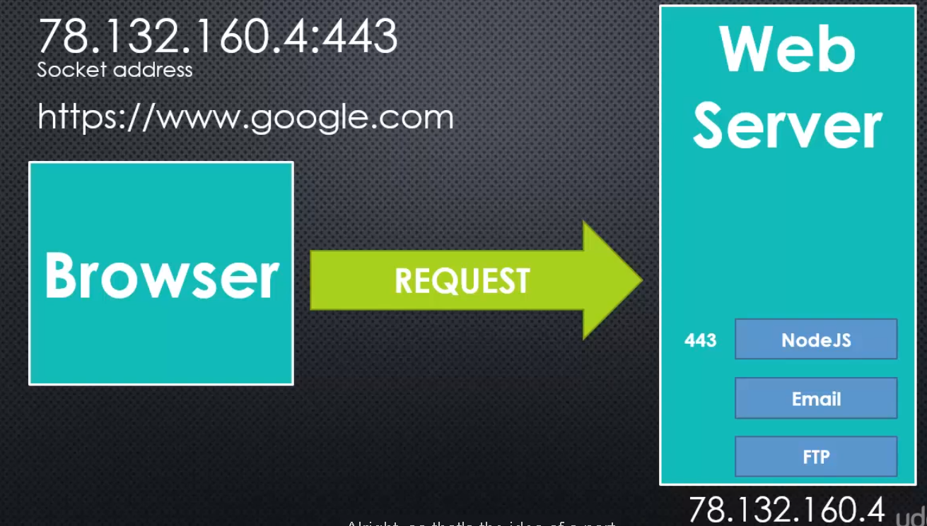

we have the web server and the browser and the browser sends a request for an example.

**It sends it to a particular IP address, so that's how we know what server it is ultimately.**

**But on that server, maybe there are many different programmes running, and node.js is one of them. So, how do we know that node.js is the programme that should receive this information being sent to the server?**

**Well, we assign node.js a port, that is just a number that's unique and that programme will then receive the information that's sent to that port.**

We specify that as part of the address, so the IP address and then a colon, and then the number. **The number is the port, this is called the socket address** when you put it all together.

**Usually we don't deal with this directly, usually we just deal with some sort of domain name, which maps to an IP address and a port.**

## HTTP

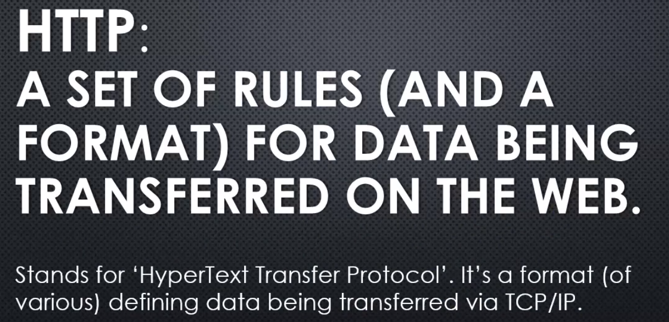

Data defined within the set of rules for how to format an HTTP request or an HTTP response is then split into packets as defined by TCP.

HTTP is used not just to send HyperText, that is html, but lots of information like JavaScript files, and images, and other things.

It's the core of how we send information on the worldwide web, web pages, web applications, and images, CSS files, JavaScript files, etc.





This is an example of an HTTP request, a very simplified example where we say here's the information I'm looking for.

Here's the port so that we know which programme should receive this information.

A couple of other things and in general, there are what's called headers which are just name value pairs separated by a colon.

So the host or the connexion is the name, and then the value is Google.com or keep-alive.

There are standards as far as what this actually means.

**The server and the browser understand what all of these different possible values mean.**

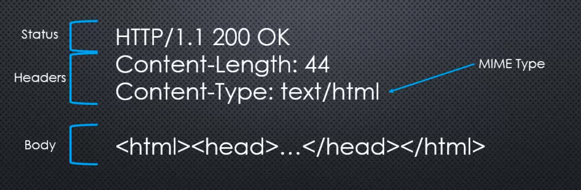

**Here we're showing some html which is very common, but it could also be the data that defines an image, json data, a JavaScript file, a CSS file, whatever we're sending across the internet defined by the HTTP concept, that protocol.**

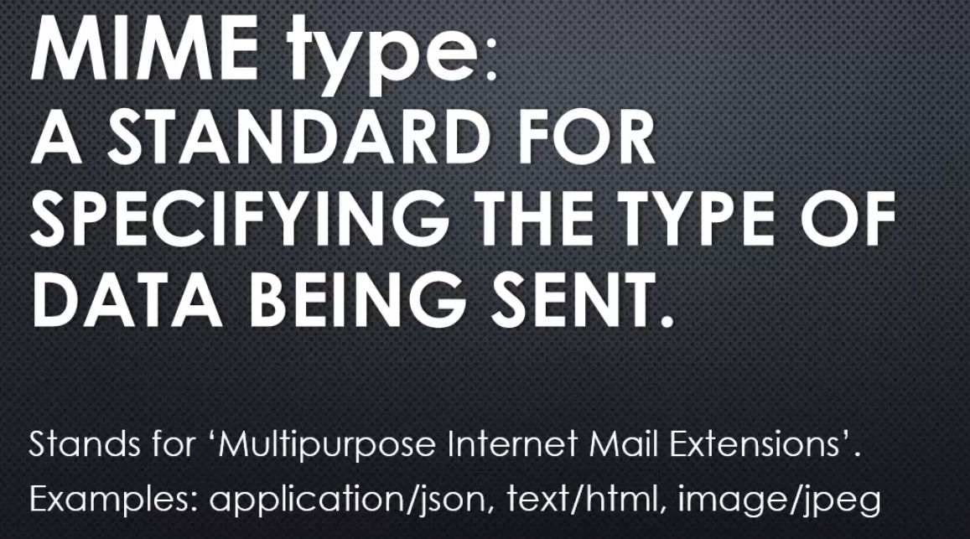

The idea is that the server and the browser understand what a MIME type is, and then it's coded to treat each particular MIME type a certain way.

**If the browser, for example, sees an image MIME type it knows you are sending an image and should display it. If it sees that you're sending html, then it knows that it should process the html and render a webpage, etc.**

## **http_Parser**

**so the question for Node.js as a web server is how do we then build HTTP requests and responses? How do we parse them?**

That is, break them up into their pieces, then use that information.

we're just talking about formatting. We're talking about putting together an HTTP response. You could almost think of it like a text file basically.

In a proper format with the headers and the body and the proper name-value pairs, and the proper statuses that can come back.

**Well, there's actually a programme embedded inside of Node.js that does that. We can take a quick look and also the javascript code that wraps it.**

Let's talk about **HTTP Parser**.

**The HTTP Parser code that is found inside the Node.js core, can be found at github.com/joyent/http-parser. And so this is a C programme and is embedded in Node,**

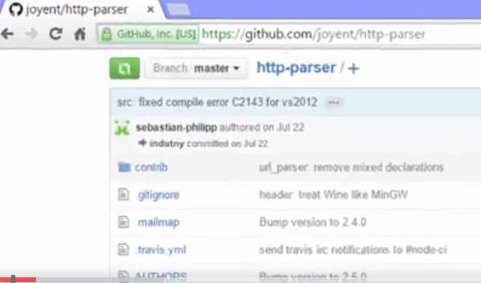

but is really a separate programme that could be used elsewhere. And what it does is it parses requests and responses. it breaks apart the kind of things that come along for the ride like headers, those name-value pairs, and the version, the body of the message, the status codes.

So it can look at an HTTP request and it can look at an HTTP response, and it can break it apart for us, and then we can then have those different pieces of data as separate pieces of data, and then make decisions with them.

**it's just a bunch of C code. And if you know C, you can go right in here and take a look, and see what it's really doing. But we can also see that there's more going on because the HTTP parser is wrapped inside of the Node.js javascript side of the core, and also other features added to it in javascript itself.**

If I open up the javascript side of the **Node.js source code, I can find in the left folder an http.js file, and that's what I would require in order to get access to these abilities of creating HTTP request and responses.**

There's also an HTTPS file for dealing with securing encrypted connexions.

But we'll see inside this http.js file that it's actually using a number of things. It's going to use the event emitter, no surprise there.

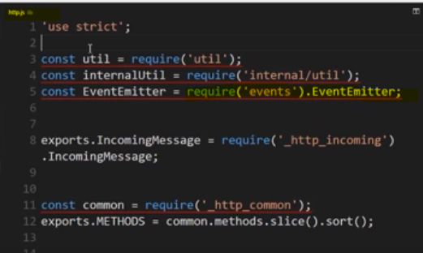

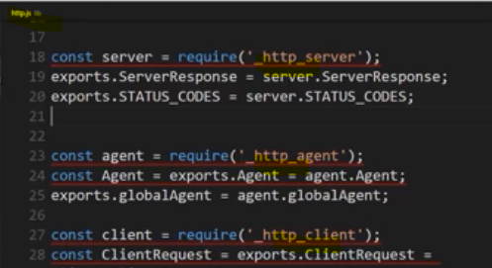

it also is going to use a number of different modules that start with _http with a node javascript modules, common, outgoing, http_server, agent and client.

**Node.js is coded not just to be able to respond and send HTTP responses, but it can also go out and request information from the internet, elsewhere on the internet itself and make an HTTP request.**

**take a look for example at _http_server.js it grabs the HTTP parser, it wraps it. It gets that code, that feature, from the C++ side of the core.**

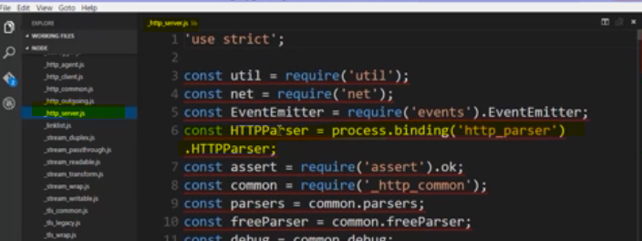

 it adds on other concepts, like we have a list of the status codes, the different statuses that could come back. From an HTTP response, it wraps the idea of a response coming back from the server with a number of features and different methods that can be called on it. We have the ability to write a header that is at our own name-value pair, a header that will be part of what is created when that HTTP response is put together, and it's really a string that's being put together. We have a status line, that first line we saw. And the code that defines if everything's okay or not, or what has happened as far as this response is concerned, if there's an error or otherwise.

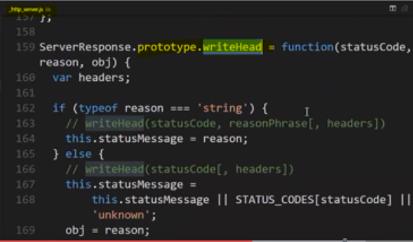

**Lets again look into http.js**

**I can actually find a method called createServer. And it says "give me a listener." So in other words, a function that will be invoked whenever information is sent to me. So, when an HTTP request shows up, then run this function, and that function will then handle what it should do with that request, and it will also give that function the ability to respond to that request. And that's what a server does, it accepts requests and it gives a response.**

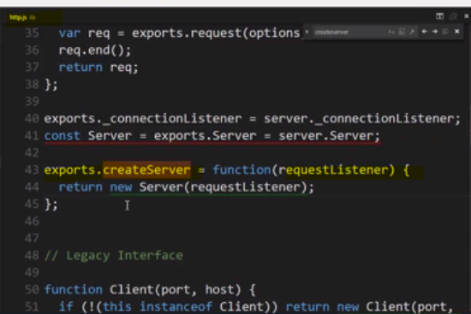

**Alright so, when we want to create our own server in Node, we have all the pieces that we need. We have the ability to connect to the internet, to send a request, or to receive a request and to send a response. So, now we're ready to use this HTTP module and the other things that we've learned to build a web server in Node.**

## **Build a WebServer in node**

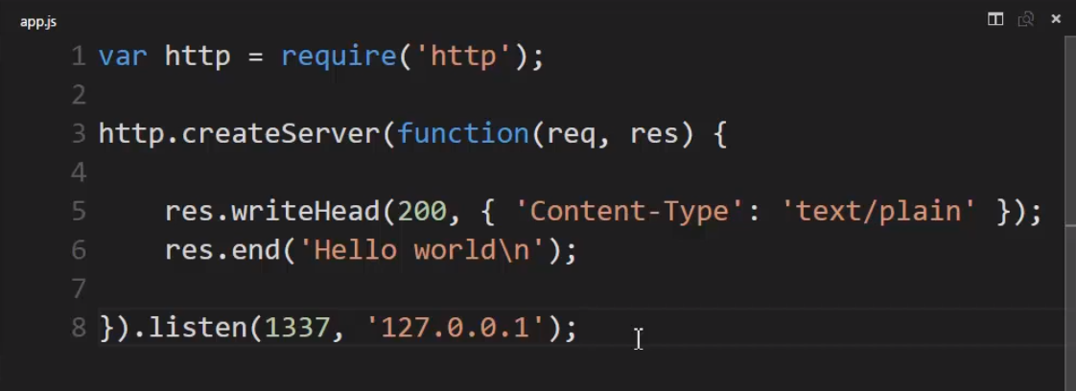

creates a new server object. And this call to this function takes a callback, a function that I pass to it to be invoked, and this turns out to actually be an event listener so that when the server object emits a particular event, this function will be called.

If I dig back into the bowels of the node js source code, in the underscore http underscore server dot js file, deep down in the node js source code, I see that this server object, which is an event emitter, meaning that it is faking events, it has an events object that has a request property on it, and when I gave it that function, it will invoke it when a request occurs, and it will pass to the function that I give it two objects, one representing the request, and one representing the stream where I can stream the response back. So, it gives me those two parameters in the callback.

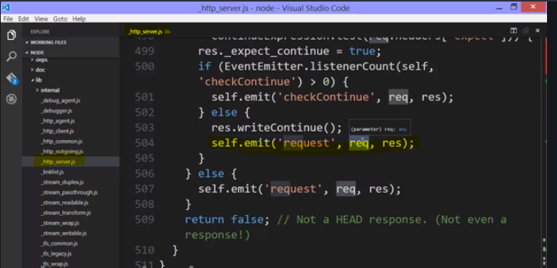



that's it, I've built the response. Now, we're missing one thing, where does node map the port?

How does it know when the information is sent to a particular port that node should receive that information so that I causes the request event to emit?

Well, createServer itself, while I give it a function, which will be invoked when the event happens, it self-creates an object, and on that server object, I have a dot listen event that I have access to. And remember, listen is just a metaphor for when information comes to the server, here's the port that, if it's sent to that port via that port portion of the address, then send it to me, please. Send it to this programme that's running. And I could listen to any number of ports.

Let's just try 1337 and then, another parameter would be the address that we would be looking for, and this is the standard internal IP address for the local system or what's sometimes called local host. So that means if I type local host in my browser, that will translate to this IP address, and since I'm running this locally, that will work and 1337 would be the port.

In other words, I would put local host colon 1337, and that means that when the browser makes this request, then this process will receive that request, and the HTTP parser wrapped up inside that JavaScript code will give me the request, and then I can send back the response.

**So we understand the require function and getting from the node js core. We understand, then, that this is creating an object and giving a callback, which actually is turned into an event listener using the event emitter code inside node js, and that I have an HTTP request and a response, which has some methods which allows me to send information back down the stream, things like the status and the headers that our information at the browser will use to interpret what I'm sending and the body of the data itself that I'm sending, and that node js will take all this information and create a properly formatted HTTP response that the browser can then understand and is programmed to do things with, and ultimately, this listen for the port and address will make sure that that request from the browser is routed properly to this code ultimately.**

**When I run it**

 it runs, but notice it's still sitting there waiting. The programme continues to run because when I created this server, that caused some code to run that simply sits there and waits for a request. So the node programme doesn't stop. It doesn't exit out of the programme code. It just sits there and keeps running, waiting for a request. So, we need to give it a request.

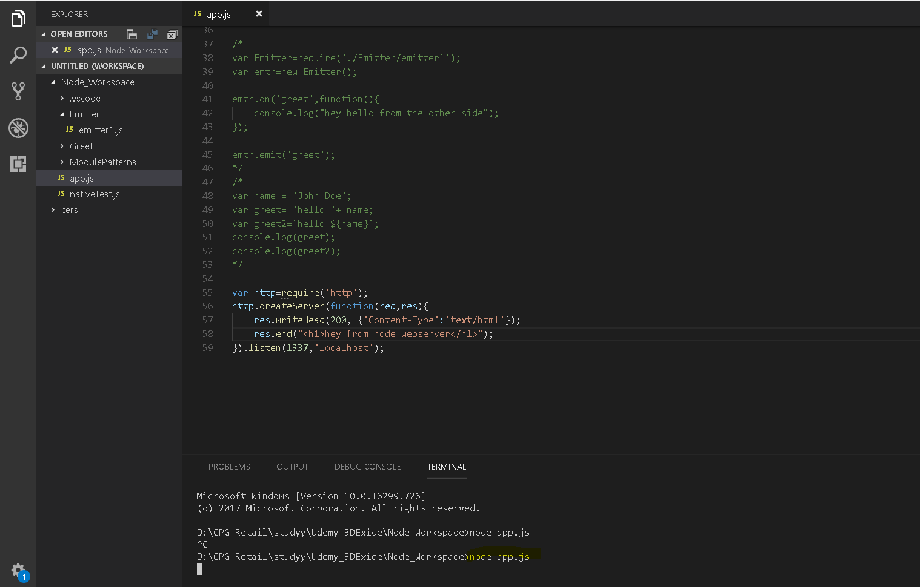

**The program is waiting for request continuosly, so I made a request in browser**

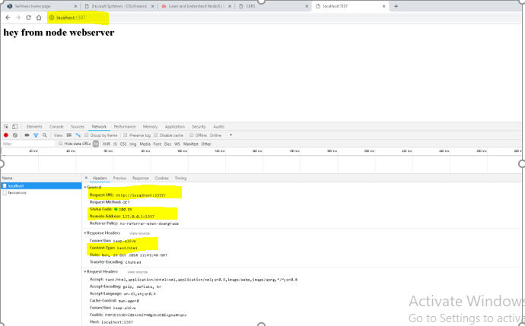

We can see that the URL that we asked for was actually translated to that internal address in the port, and we can see that what came back from the response was that content-type text/html that I specified, as well as some other things that node js did for me. So, I didn't have to think about everything. Also, there's that status code, and the browser knows that 200 meant OK. And if I scroll down, we can see the headers that the browser created for its request that was sent to node.

A lot of things there that node also is programmed to understand.

If it would have be text/plain as my content-type, as my MIME type, the browser was programmed, the programmers of this browser said, well, if it's just plain text and not HTML, we'll just output the text. We won't try to figure out, like you do with HTML

**Lets try to debug whats going on**

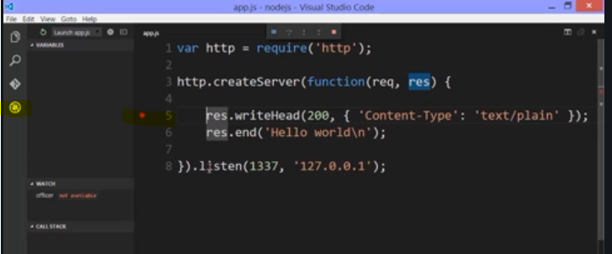

**Lets see what req object contains** 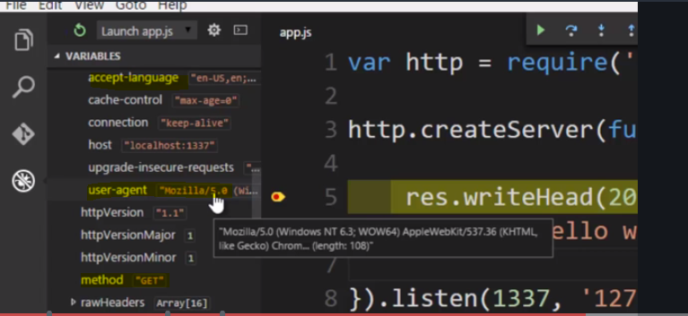

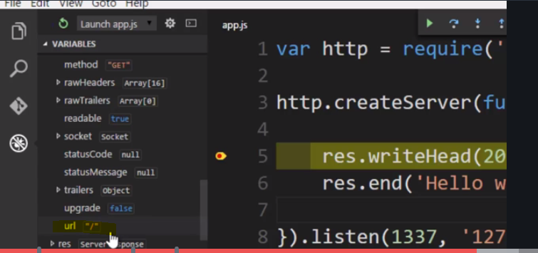

**Lets look into res object** 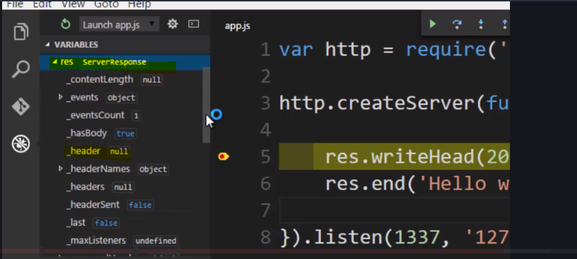

I got my response back, and that was made possible for me by this code. So, let's stop this and stop and think about this.

**With just these few lines of code, I was able to build a working web server that accepts HTTP requests and gives me a way to look at them and build an HTTP response and have something show up in the browser.**

It's pretty neat, right?

So, I'm not totally abstracted away from what's going on, but I'm pretty abstracted away. I don't have to think about an awful lot of things that are happening under the hood.

This is why this example is so popular, and people talk about node because so much is happening here. And yet, it's so little code that I actually have to write in order to get a web server going.

## Outputting HTML and templates

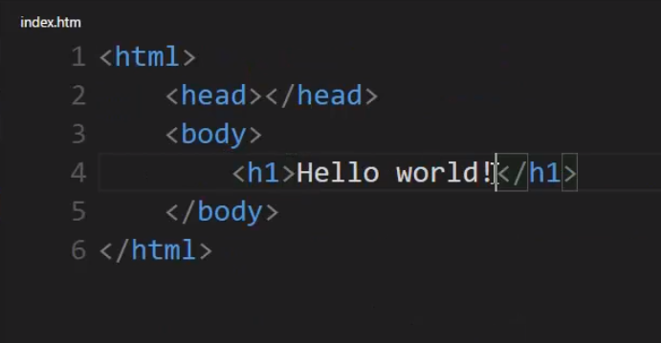

Output - 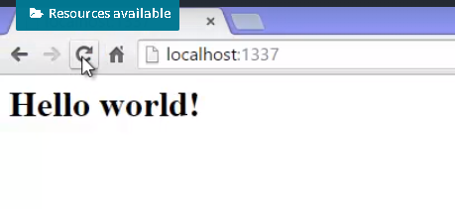

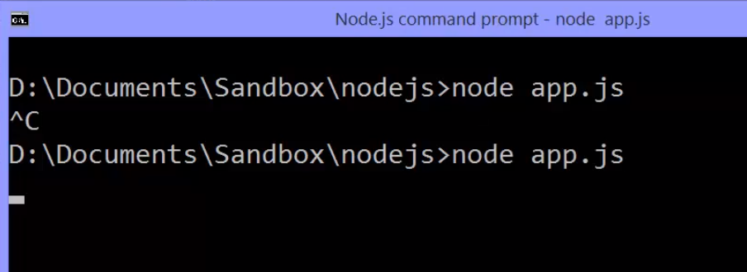



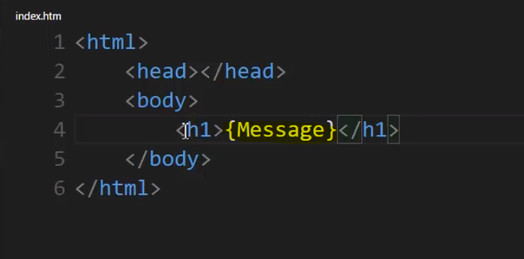

So I have my template, which is my HTML content in this case, just a placeholder.

I put curly braces to make it easy to find

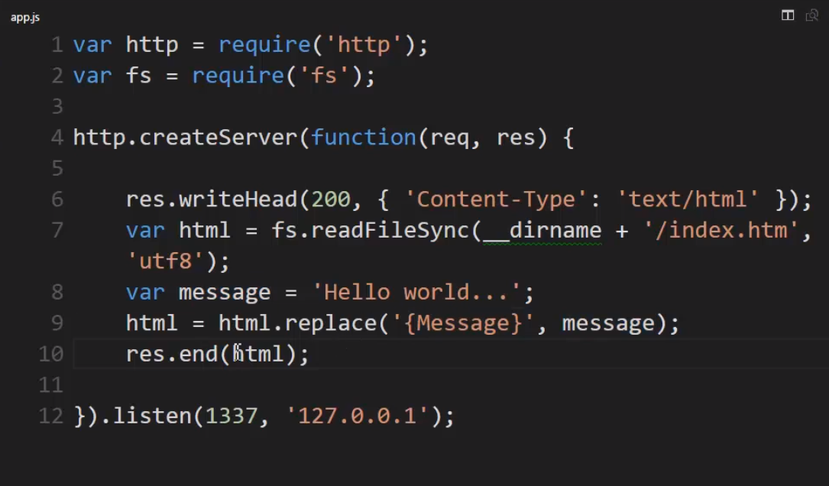 **the first thing is I need to manipulate this as a string. readFileSync is giving me back a buffer so what I really need to do is convert this to a string telling it what character incoding character set I'm using.**

So I'll say, utf8 and that way I'll actually have a string and then I'll create some variable, let's say Hello world as the contents, and because this is now a string because I specified that I want to decode it into a string I can then use the replace method. So I'll say html equals and I replace it with, and I'll use the replace method on the string to say replace message with my variable contents.

**So this let's me build what's called Dynamic Templates. Templates that are dynamically or on-the-fly being updated and changed before being sent back as a response. The request happened and then I took the template and did something programmatic with it before sending it back.**

## Streams and Performance

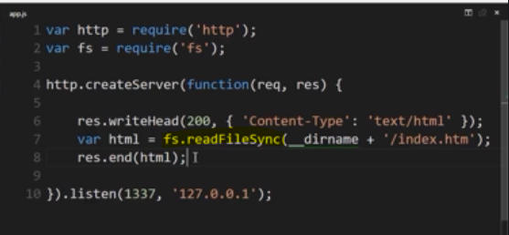

let's go back to our simplest example of pulling HTML from the file, and just having the contents, and then we read it synchronously, and then sent it to the response stream.

The problem here is that it's a synchronous call, meaning that what will happen when someone, in their browser, makes the request, every time someone makes the request, the JavaScript for that particular person running that request will stop, will fill a buffer with the full contents of the file, and then send it all back.

That means if this website, if this URL became very popular, we could end up having problems with memory if the file was extremely large.

So the idea of using streams is fundamental to improving performance. We've seen that. So how could we re-write this in order to use streams? Well it's very simple to get a stream connected, a readable stream, to this index.htm file. I just say fs.createReadStream.

Now what can I do with a readable stream?

Well remember streams are just a wrapper around the idea of dealing with data a chunk at a time. So in this case we're reading a file, but I could send the chunk to any writeable stream. And what's the writeable stream that I already have available to me?

That's right, the response, that was passed to me when this event listener, given as a callback, was invoked.

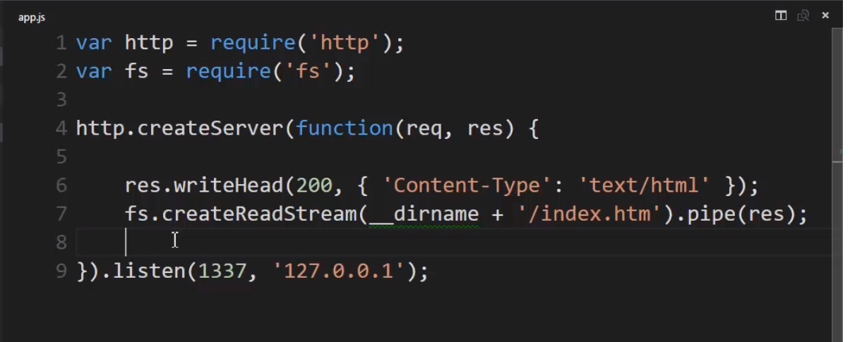

**So every chunk of data read from the file will be buffered and then piped out to the HTTP response stream. So rather than pulling the entire file into a buffer and then sending it, we'll send it a chunk at a time. Our buffer stays small, and that means our application will be faster, more responsive, more performant.**

So instead of waiting, the code can just run and start the stream, and as we get a chunk of data from the file, it gets piped out, and since a TCP/IP connexion is a stream anyway, is sent in chunks, the browser's already used to dealing with data coming a chunk at a time, and then processing it after it's downloaded, or even as it's downloading like you would for example in a streaming video. So since streams are fundamental to how the internet works anyway, this works perfectly.

Now what if I had wanted to replace the contents as it goes? Well I'd need to write a custom stream that dealt with the fact that I might not have the whole string to replace. I'd have to look at the chunk, see what string I have, find where maybe a placeholder starts, and see if it ends within that chunk or maybe ends in the next chunk. But that seems doable. Now that's not built into NodeJS the core, but the concept of streams is, and this ability to pipe between different kinds of core streams, so we could build on that. We could grab a full file when necessary, like an image or a CSS file, and just pipe it straight out. Or we could do something fancier when we need to manipulate something like a template.

**the core idea of using streams to improve performance. Remember this in your real-world Node applications. Use streams wherever you can, and when you don't use them, make sure it's on purpose.**

## **APIs and Endpoints**

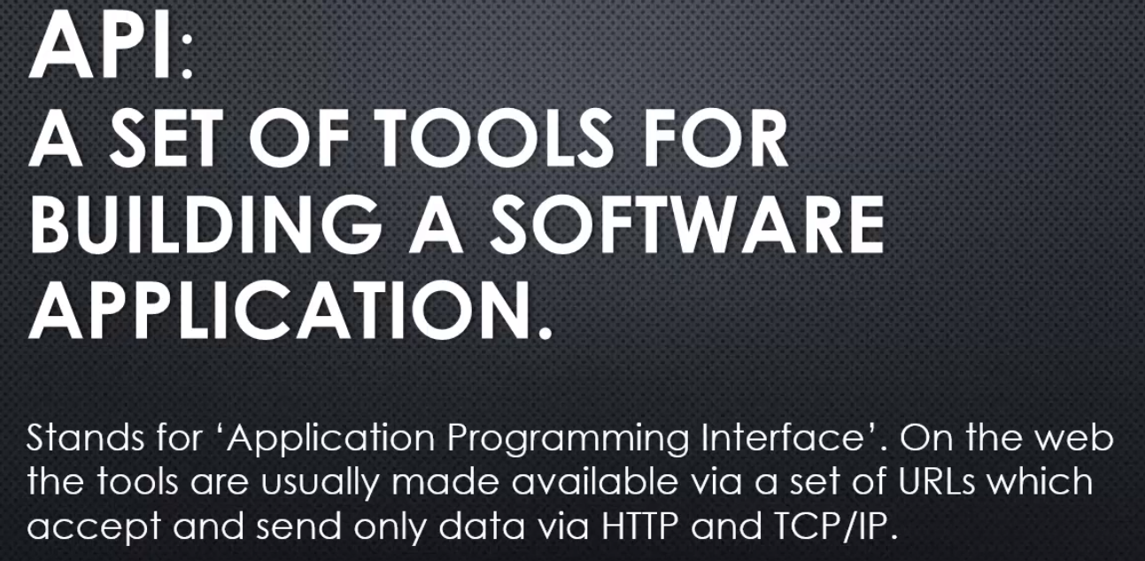

So, in other words, a URL that you go to, that instead of returning a web application, gives you back data. And, you can send data. Send an HTTP request to that URL with data as part of the HTTP request, and the API will do something with that data.

In fact, that **URL itself is called an endpoint.**

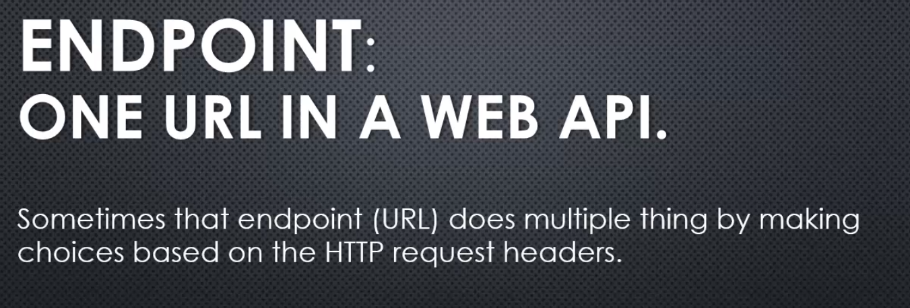

So, in my HTTP request, I might put my data, but I also might put something in the header, some other name value pair that has a particular meaning to that API endpoint.

Maybe it will give me data with one header, and delete the data if I put a different header. So, I can reuse the same URL, and there's some logic behind that code that that URL causes to run that will look at the HTTP header, like we did with our request object, and make a choice.

they give and receive data in a particular format, or sometimes multiple formats they'll accept, and the most popular, these days, is JSON. And that's great, because JavaScript is really good at JSON,

## **Outputting JSON**

**If I do this , like sending data without converting it into JSON-**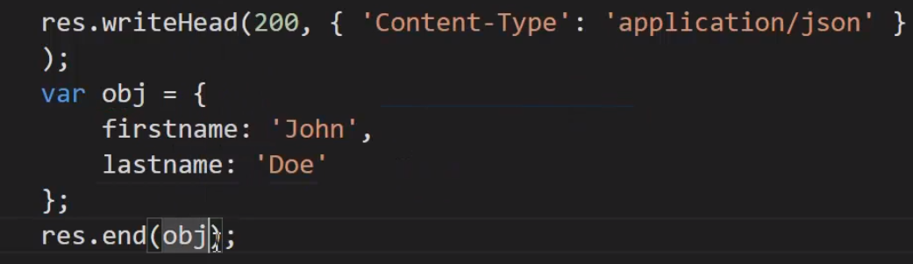

**Then it will be shown as [object object]**

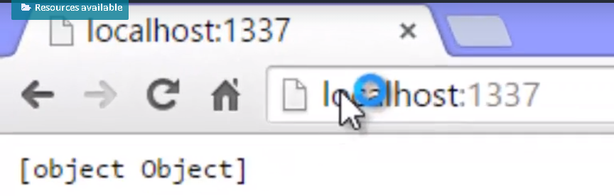

**So we need to convert it into JSON representation of string.**

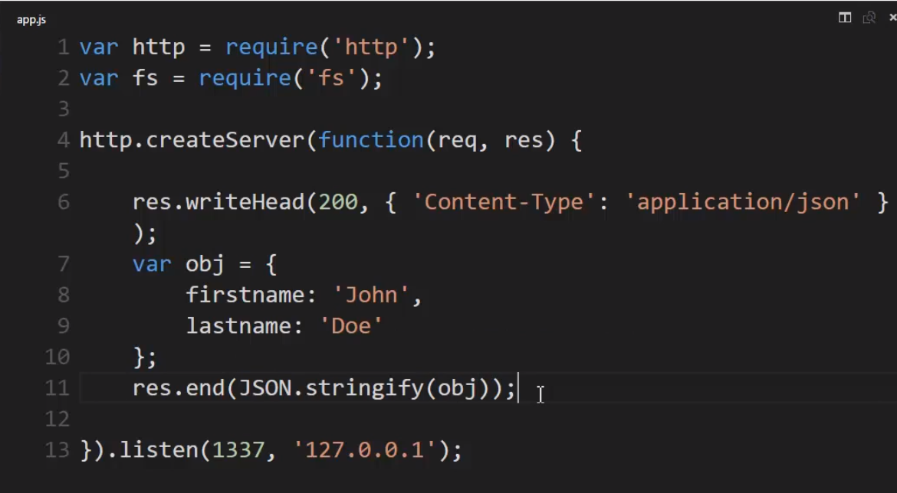

But, the good thing is, JavaScript, and therefore the v8 engine is implemented, some nice ways of dealing with JSON data. So, built right into the engine,

I could say, **JSON.stringify** and give it an object, so it will take the object and convert it to a string, and the string will be formatted as JSON,

and since JavaScript is so good with JSON, I could convert the JSON back to an object. Essentially, I can have an object over in node.js, on the server, very easily converted to JSON, that is, serialise it.

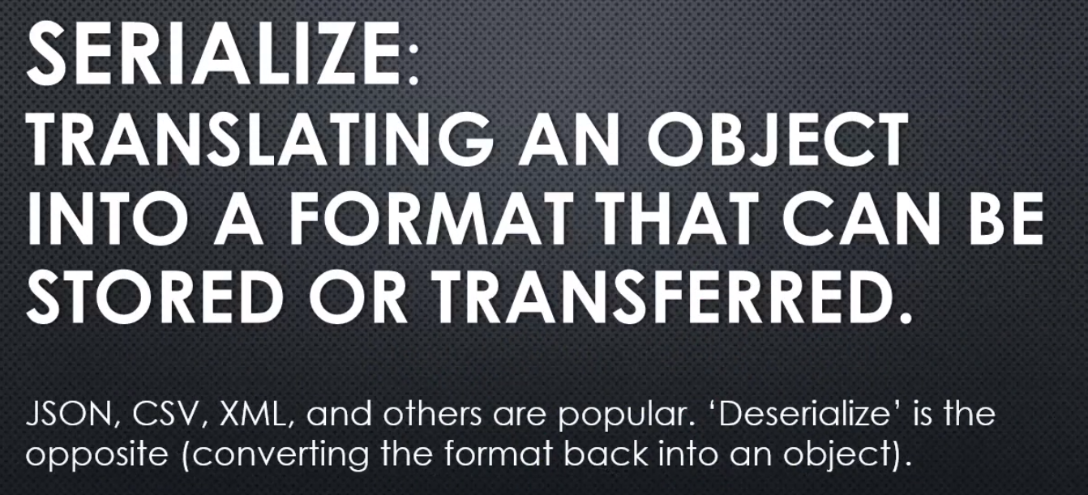

What we're saying is that, it was very easy for us to take an object in memory and serialise it, that is converted into a format that could be stored or transferred, in this case, JSON as built in to the v8 engine, the ability to do that and then over on the browser side, it could then receive this text, and since there's a JavaScript engine sitting inside your browser, it can then take the JSON and convert that to a JavaScript object. And so, we're in that way, through serialization on the node side and deserialization on the browser side.

**Getting data from the API endpoint and then we could use this to display the data or manipulate the data in JavaScript I might have running on the browser, that is the JavaScript downloaded by the browser, some JSON file, and that's included in the script tag, in the HTML. And vice versa is true, I could serialise some JavaScript data, maybe something the user entered on the screen and then, serialise that to JSON, send it to node as a JSON string, and then just be able to say, "okay, now it's an object, serialise it, and then, deserialize it in node."**

And of course, because this is an API, it doesn't have to be the browser that uses this data. Maybe someone in PHP or in asp.net or Ruby on Rails or a different node programme, will come out and grab this data from this url. That's okay, we don't care, because this is just a tool to be able to build other software.

## **Routing**

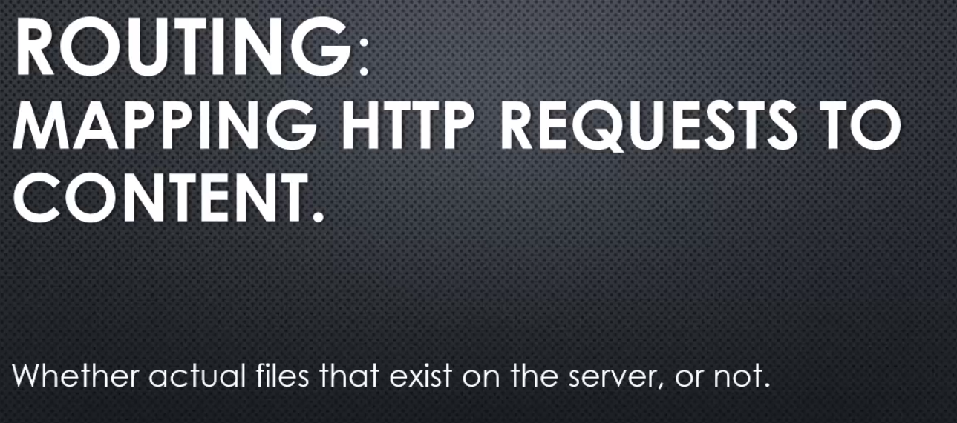

the route will map the request to content.

**Because realise when you request a file on the internet to download it, you're not directly connecting to the file, you're connecting to the server and saying, please give me this. And it may be that the server is doing various things to give you that content. It might be, pulling a file off the server, it might be getting data from a database, it might be building HTML on the fly.**

You don't really know.

And so when we're building routing, we're just saying when someone gives me a request for something specific, I'll give content back to them. I'll stream the content back to them. And how I deal with the content internally, well that's up to me.

So, let's look at routing at a very simple level.

Now, we want to respond more properly to different URLs, that come in the HTTP request. **Because right now, and this may surprise you, every URL we send to Node will give me back the same data.**

Ex1-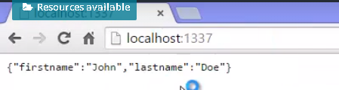

Ex2-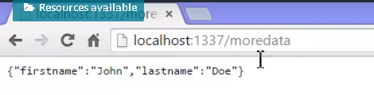

Ex3 - 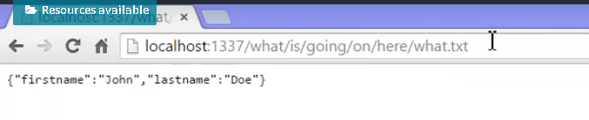

Alright, so why?

You may be thinking, well that file doesn't exist. That's right.

But again, all that's happening, all the browser is doing, is sending an HTTP request. And the URL is one of those pieces of data in that request.

And it's up to the server as to what to do with it. And so, in our case with our code **so far, we aren't even looking at the URL.**

**We're just saying, here's the response. Here's the HTTP response for a request. For any request.**

So, what we want to do is look at the URL passed in the request and choose to give different content based on those different URL's.

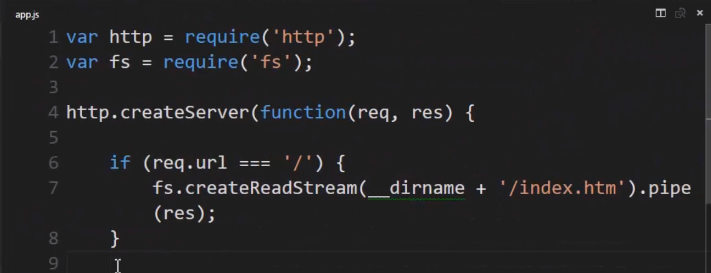

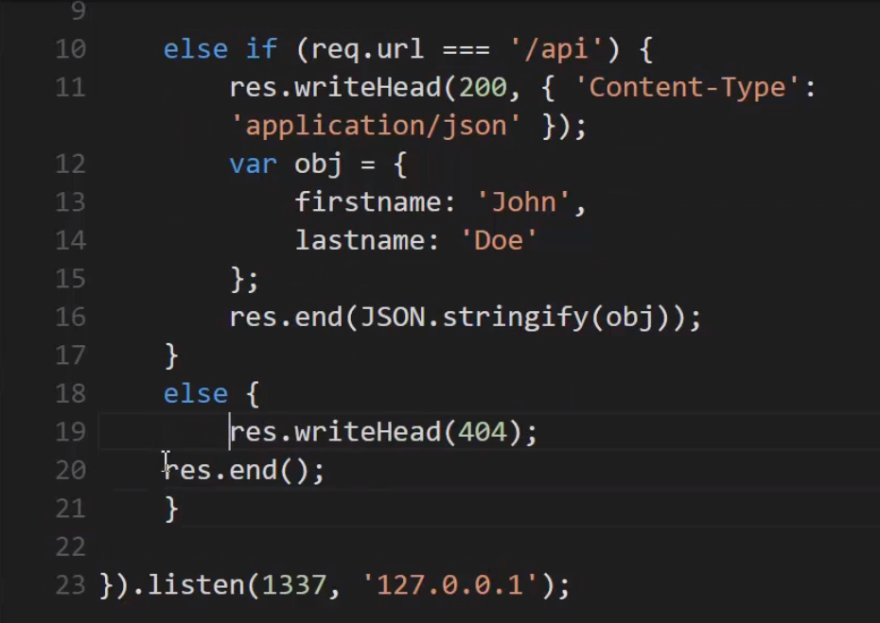

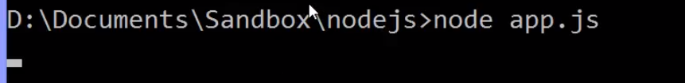

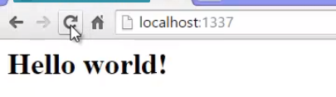

Alright so, the HTTP request came in, the URL was just slash, meaning there was nothing at the end of this, it was just a slash. And I return the contents, I streamed the contents of the HTM file

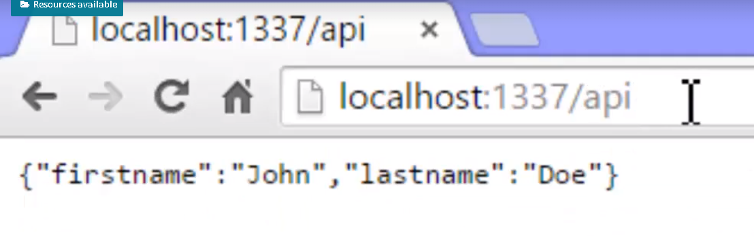

**if something doesn't exist, I'll just put at the end here, outside my if statements, write head 404, let's say. And, I'll just end it with nothing.**

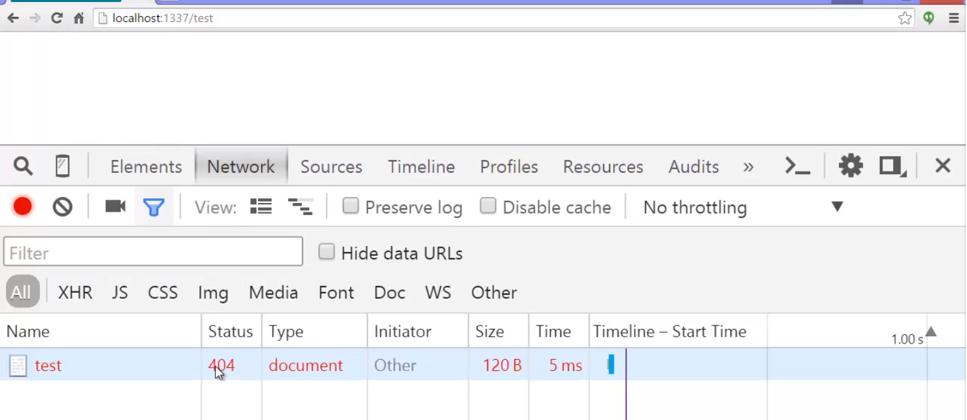

what if I wanted patterns instead of just straight URL's?

What if I had something like a shopping cart. Where I was looking at t-shirts, and each one had an ID, like 101, 102, 103.

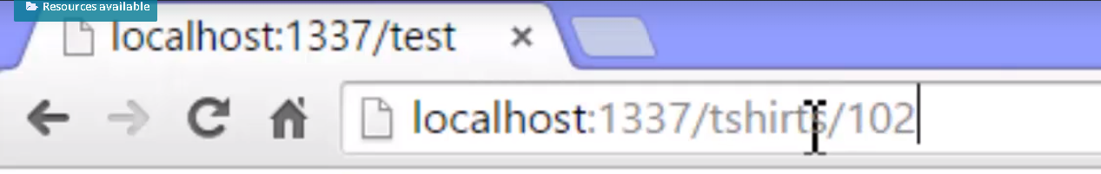

I wouldn't want to have to write a separate URL piece of logic for that. I might want something where I look at the end of the URL and use that as a variable,

and then decide which one to pull from the database based on that, and other things.

So routing gets complicated. We could do it ourselves, but it would be awfully nice if we had some kind of tool, a bunch of JavaScript code written for us, that would do that.

65. WebServer checklist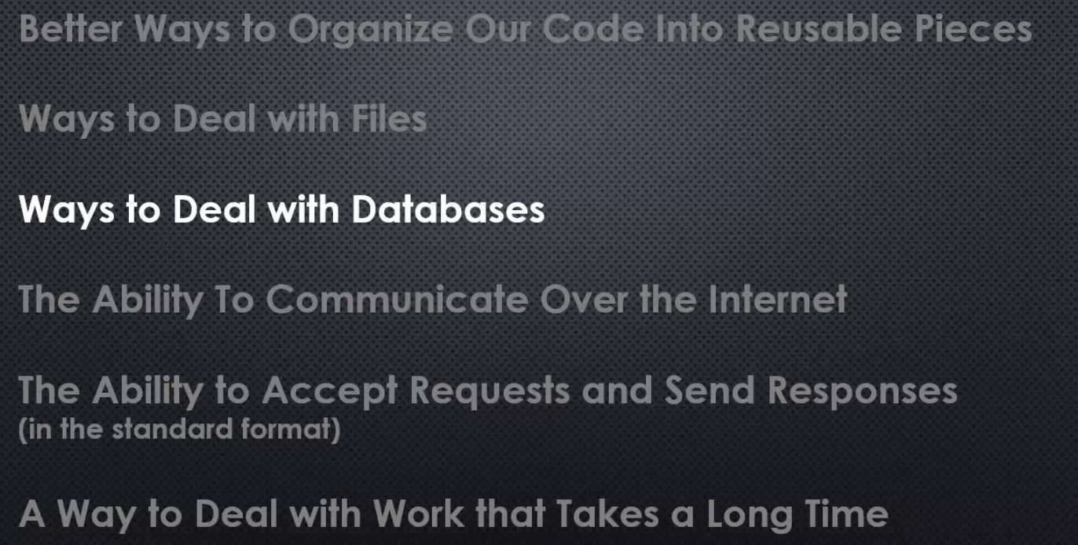

Now, we've seen that we have the ability to communicate over the internet, that Node under the hood has that connexion through the operating system to be able to deal with TCP IP, and we've also seen that the messages that we send back and forth are built in as well and the format is HTTP, another protocol, and in that standard format we can receive an HTTP request or send an HTTP request, and send and receive a response, and that allows us to serve as a web server.

Now, **we've been saying that there are some things that we can do but would be nice if we didn't have to do them ourselves, hand code them, if someone else had coded them for us and we could just use it. Well, we're going to talk about just that.**

**There are a number of utilities to do those kinds of things for us, popular ones like KOA, K-O-A, for example,**

**but the one we're going to focus on is the most popular and most common, it's called Express, and it's a bunch of JavaScript code that's been written for us to do the kinds of things we've been talking about.**

Now, that said, we first have to answer the question how do we instal all of that JavaScript code into our Node application? **Well, thanks to Node modules that came along before JavaScript supported modules natively something happened, an explosion of open source, free-to-use, free-to-see-how-it-works JavaScript code. In fact, Node is responsible for the largest open source ecosystem of code in history. So, next we'll look at NPM and the NPM registry.**